SUMMATIVE ASSESSMENT
- Use the following table to construct an explanation and a bar graph regarding the speed of sound through different media.
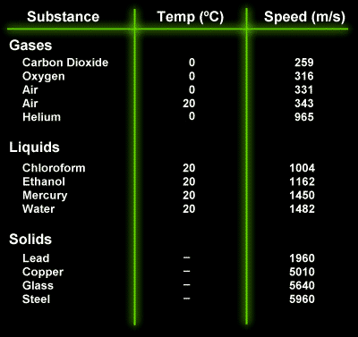

- For light use the following equation to calculate the speed of light through different media. Construct an explanation and bar graph using the speed you calculate.
FORMULA: $v= \frac{3.0 x {10}^{8}}{n}$
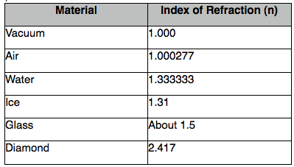

- Sound Explanation:

- Light Explanation:

- Compare and contrast the speed of light and sound in different media. What trends did you find?

