SUMMATIVE ASSESSMENT
- Use the following table to construct an explanation and a bar graph regarding the speed of sound through different media.
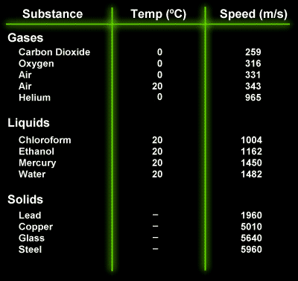

- For light use the following equation to calculate the speed of light through different media. Construct an explanation and bar graph using the speed you calculate.
FORMULA: $v= \frac{3.0 x {10}^{8}}{n}$
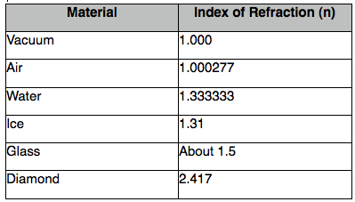

- Sound Explanation: (+15)
The speed of sound in solids is the fastest and speed of sound in gases is the slowest. The temperature in gases has a direct effect on the speed of sound.
Graphs (+20)

- Light Explanation: (+15)
The speed of light is greatest in the least dense materials (vaccums) and slowest in the denser materials (diamonds).
Graphs (+20)
Speed Calculation Answers (Show work) (+10 total 2 points per calculation)
Vaccum = 3.0 x 10⁸ m/s
Air: 2.99 x 10⁸ m/s
Water: 2.25 x 10⁸ m/s
Ice: 2.29 x 10⁸ m/s
Glass: 2.0 x 10⁸ m/s
Diamond: 1.24 x 10⁸ m/s

- Compare and contrast the speed of light and sound in different media. What trends did you find? (+20)
Light and sound waves are the opposite in terms of the speed in which they travel. Sound travels faster in objects that have particles closer together because sound is a mechanical wave and requires a medium. Light is slowed down by particles because it is an electromagnetic wave and does not require a medium. Light can behave like a particle which means other particles would slow it down.

